Name:________________ Date:_____________

The table below is from a sample from a larger data set collected on people discharged from a selected Pennsylvania hospital as part of a retrospective chart review of antibiotic usage in hospitals.

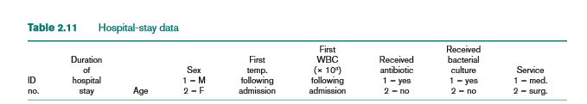

**Import the hospital dataset in the SAS to answer the questions below.**

**Question 1.** What is the distribution regarding gender in the dataset? Please provide a contingency table (with count and percent) to show the distribution of the variable. Paste results from SAS here.

Test whether there is an association between whether a patient received bacterial culture and the service the patient received? **Use the information to answer questions 2-4.**

**Question 2**. Perform a chi-square test and provide the contingency table from the test. Paste results from SAS here.

**Question 3**. What is the chi-square test statistics?

**Question 4.** What is the p-value?

**Question 5.** What is the conclusion?